**DAILY ONLINE ACTIVITIES SUMMARY**

|  |  |  |  |  |  |  |  |  |
| --- | --- | --- | --- | --- | --- | --- | --- | --- |
| **Date:** | **10/06/2020** | | | | | **Name:** | **NAIPUNYA VINOD NAIK** | |
| **Sem & Sec** | **IV SEM & A SECTION** | | | | | **USN:** | **4AL18CS050** | |
| **Online Test Summary** | | | | | | | | |
| **Subject** | | **OBJECT ORIENTED CONCEPTS** | | | | | | |
| **Max. Marks** | | **30** | | **Score** | | | **22** | |
| **Certification Course Summary** | | | | | | | | |
| **Course** | **INTRODUCTION TO JAVA PROGRAMMING** | | | | | | | |
| **Certificate Provider** | | | **GREAT LEARNING ACADEMY** | | **Duration** | | | **5.5 HRS** |
| **Coding Challenges** | | | | | | | | |
| **Problem Statement:1)** [Write a C Program to print the sum of boundary elements of a matrix](https://github.com/orgs/alvas-education-foundation/teams/2nd-year/discussions/112).  2) Write a Java Program to find the longest repeating sequence in a string. | | | | | | | | |
| **Status: EXECUTED** | | | | | | | | |
| **Uploaded the report in Github** | | | | | **YES** | | | |
| **If yes Repository name** | | | | | <https://github.com/naipunya-naik/lockdown-coding/blob/master/JAVA%20CODING/RepeatingSequence_10-06-2020.java>  <https://github.com/naipunya-naik/lockdown-coding/blob/master/C%20CODING/Boundaryele_10-06-2020.c> | | | |
| **Uploaded the report in slack** | | | | | **YES** | | | |

Online Test Details: (Attach the snapshot and briefly write the report for the same).

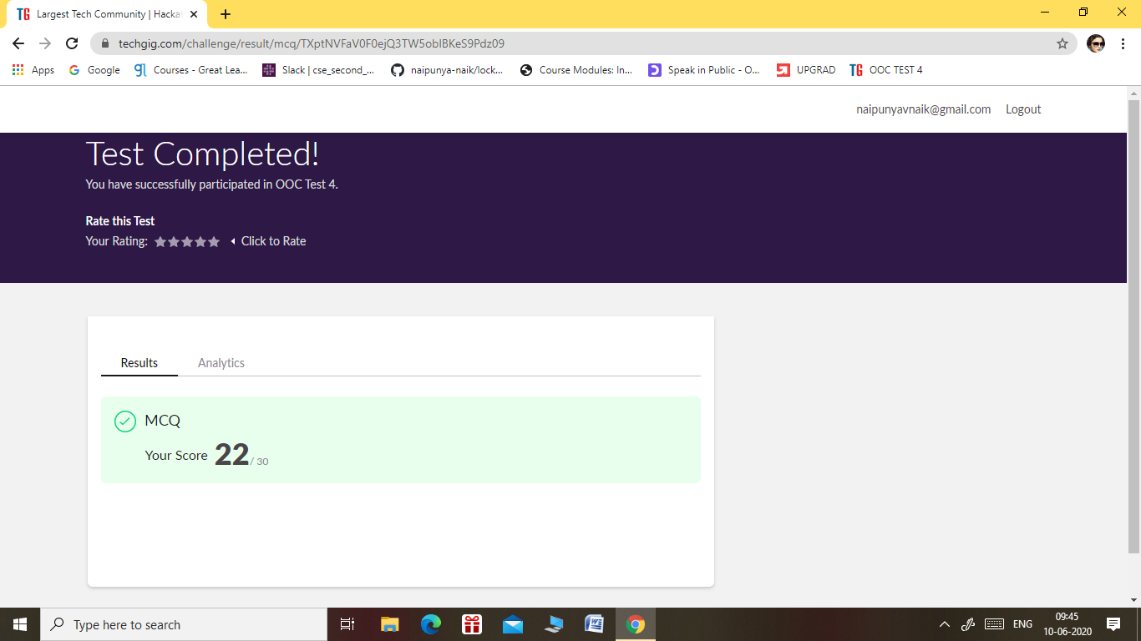

* THE 4TH I.A TEST OF SUBJECT OBJECT ORIENTED CONCEPTS WAS CONDUCTED ON 10 JUNE 2020.
* SUBJECT:- OBJECT ORIENTED CONCEPTS
* SYLLABUS:- MODULE 3 & MODULE 4
* NO. OF QUESTIONS:- 15
* START TIME:- 9.15 AM
* END TIME:- 9.45 AM
* DURATION:- 30 MIN
* EACH QUESTION CARRIED 2 MARK

Certification Course Details: (Attach the snapshot and briefly write the report for the same).

* ON JUNE 8, 2020 I ATTENDED A WEBINAR ON E-COMMERCE 101.
* TODAY ON 10 JUNE 2020, I RECEIVED THE CERTIFICATE OF IIDE.



CERTIFICATION COURSE NAME:- INTRODUCTION TO PROGRAMMING

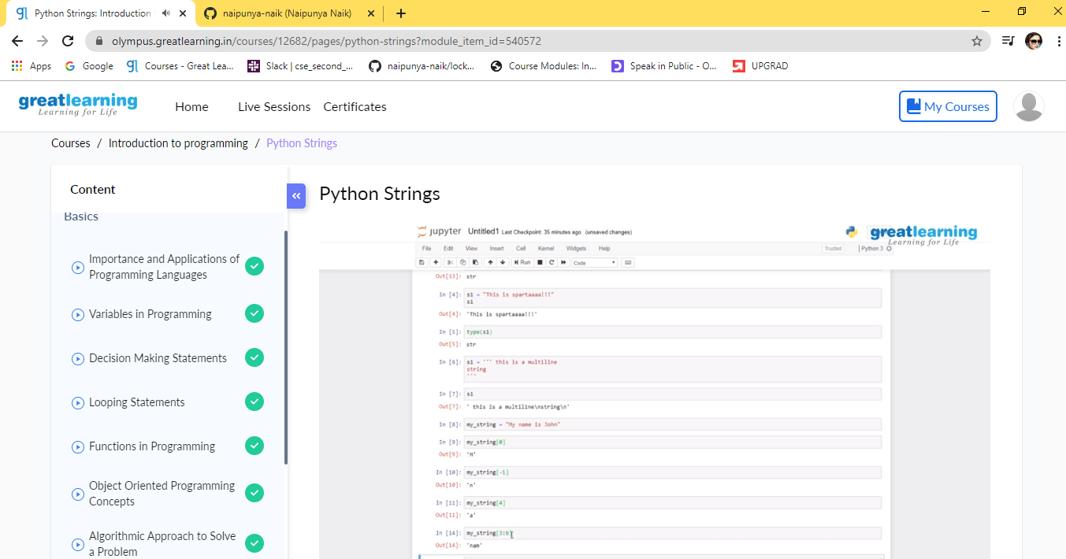

TOPICS LEARNT ON 10 JUNE 2020:-

1. [Python Strings](https://olympus.greatlearning.in/courses/12682/pages/python-strings?module_item_id=540572)
2. [Python Tuples](https://olympus.greatlearning.in/courses/12682/pages/python-tuples?module_item_id=540573)
3. [List in Python](https://olympus.greatlearning.in/courses/12682/pages/list-in-python?module_item_id=540574)
4. [Dictionary in Python](https://olympus.greatlearning.in/courses/12682/pages/dictionary-in-python?module_item_id=540575)
5. [Set in Python](https://olympus.greatlearning.in/courses/12682/pages/set-in-python?module_item_id=540576)
6. [If Statement in Python](https://olympus.greatlearning.in/courses/12682/pages/if-statement-in-python?module_item_id=540577)
7. [Looping Statements in Python](https://olympus.greatlearning.in/courses/12682/pages/looping-statements-in-python?module_item_id=540578)
8. [Basic Problems in Python](https://olympus.greatlearning.in/courses/12682/pages/basic-problems-in-python?module_item_id=540579)

Coding Challenges Details: (Attach the snapshot and briefly write the report for the same)

PROBLEM STATEMENT 1) :-[Write a C Program to print the sum of boundary elements of a matrix](https://github.com/orgs/alvas-education-foundation/teams/2nd-year/discussions/112)

Top of Form

Bottom of Form

|  |
| --- |
| Given a matrix, the task is to print the boundary elements of the matrix and display their sum. Sample Output 1: Enter M (Rows) and N (Columns): 3, 3 Enter the Elements: 1 2 3 4 5 6 7 8 9 OUTPUT: The Input Matrix is: 1 2 3 4 5 6 7 8 9 The Boundary Elements are: 1 2 3 4 6 7 8 9 The Sum of Boundary elements of the Matrix is: 40  Sample Output 2: Enter M (Rows) and N (Columns): 4, 5 Enter the Elements: 1 2 3 4 5 6 7 8 9 10 11 12 13 14 15 16 17 18 19 20 OUTPUT: The Input Matrix is: 1 2 3 4 5 6 7 8 9 10 11 12 13 14 15 16 17 18 19 20 The Boundary Elements are: 1 2 3 4 5 8 9 12 13 16 17 18 19 20 The Sum of Boundary elements of the Matrix is: 147 |

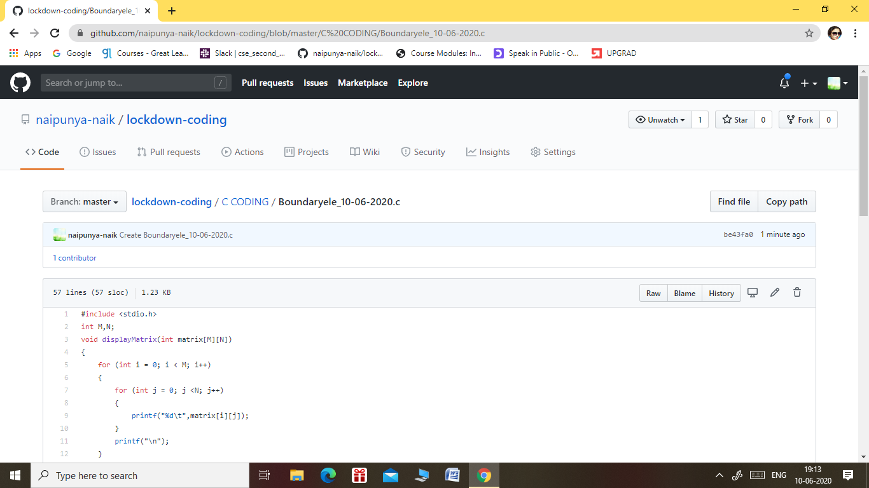

GITHUB REPOSITORY LINK:-

<https://github.com/naipunya-naik/lockdown-coding/blob/master/C%20CODING/Boundaryele_10-06-2020.c>

PROBLEM STATEMENT 2:- Write a Java Program to find the longest repeating sequence in a string. 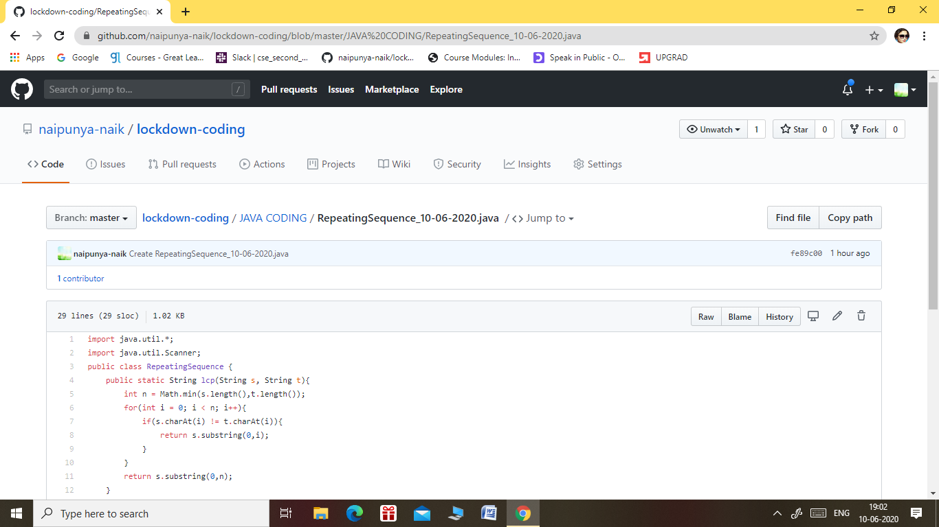

GITHUB REPOSITORY LINK:-

<https://github.com/naipunya-naik/lockdown-coding/blob/master/JAVA%20CODING/RepeatingSequence_10-06-2020.java>